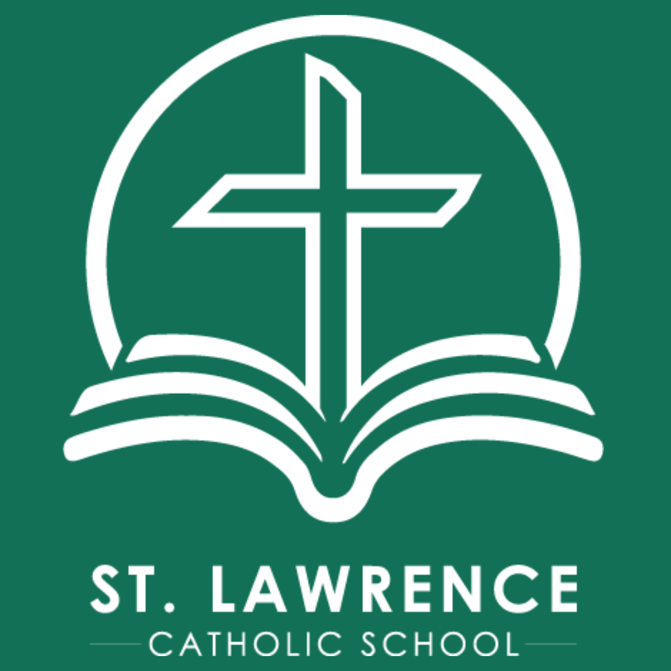
Parents Club Meeting
Friday, December 15th, 2023
Higgins Hall and Zoom

Opening Prayer
- Welcome and reminder that Zoom is capped at 100 participants
- Email Monica at stlpoints@gmail.com for your point for today’s attendance
- Next PC meeting will be on Thursday, January 18, 2024

X2vol and Commit Forms
- Thank you to all who have signed up on x2vol and are actively using the platform
- It has come to our attention that some points have not been assigned on x2vol. We are working to make sure all points are being correctly recorded. Please be patient.

Pot of Gold – Andrea Caballero, POG chair
- Thank you to all who participated in POG of this year – a special thank you to our school and parish families
- Today was our last POG raffle with the $5000 winner!
- Our largest fundraiser for STL, raising $96,316!!
- Thank you reception will be held in Jan 2024

Gala Update- Matt, Gala Chair
- Gala will take place on Sat, Feb 3, 2024
- We are blessed to announce that there has been a tremendous amount of interest and we have reached maximum capacity for the event
- This year we are fundraising for The Arts at STL: visual, musical and technology arts
- Online and live auction items have been added to our online bidding platform QTEGO and you can take a look and start bidding! Class projects are online and open for bidding
- Over the next month or so, we will be collecting donations for additional auction Items, such as vacation getaways, giftcards, experiences, etc
- So far we have $91k for ticket sales and current sponsorships
- Volunteers will be needed for events leading up to the event and the evening of the Gala

A special thanks goes out to the Sanfilippo family, who graciously donated our Christmas tree and to Heidy Rangel who beautifully decorated the tree. The tree is beautiful!

Teacher Gifts through Parents' Club
- PC provides a small token of our appreciation to all teachers, assistants,
- faculty and staff members
- Will be given next week prior to break
- This is funded from the Parents’ Club activities fee

Parents' Club Teacher Luncheon
- The catered luncheon will take place Thursday 12/21, in Higgins Hall
- Also provided by our PC activity fees
- Huge thanks to Crisina Przybicin for chairing and organizing the event again this year

Upcoming Volunteer opportunities
- Help with Gala- lots of volunteer opportunities will be needed and will be posted on x2vol closer to event
- Catholic Schools Week, Field Day & Grandparents Day – Jan 29 – Feb 2
- Help for Friday lunches - posted through end of Jan and will be posting more time slots after break

• Reminders:
- Monday 12/18- 2pm dismissal - NO AFTERCARE
- Fri, 12/22 – last day before break, ½ day - NO AFTERCARE, pick up by 12:15pm
- Classes resume Monday, Jan. 8, 2024

MERRY CHRISTMAS TO ALL

